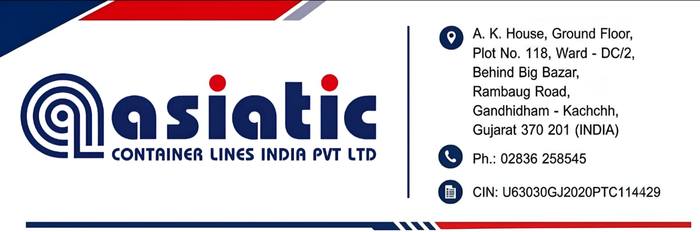
To
My Company
KNOW YOUR CUSTOMER FORM
Date : 25-08-2026 | Valid for one year only
Branch :
Sl. No. | Particulars | (To be Filled by Client)
1 | Name & Address of the Company
2 | Constitution (Whether Pvt. Ltd., LTD., Partnership, Proprietorship)
3 | Date of Establishment
4 | Permenant Account No. (PAN)
5 | Value Added Tax Registration No. (VAT)
6 | GST Number
7 | IEC CODE - Import / Export code
8 | Nature of Business
9 | Name and Address of Directors / Partners with DIN & Tel. Nos. E-Mail id :
10 | Name & Contact details of Accounts / Finance Head
11 | Details of Branch offices of the Company
12 | Name of Decision maker or person interacting on day to day basis for business
13 | Bank Details | Name & Address
13 | Bank Details | Telephone No. (Bank)
13 | Bank Details | A/c. No.
13 | Bank Details | MICR No. of the Bank
13 | Bank Details | RTGS Code No.
14 | Copy of cancelled cheque
15 | Approximate Commited volumes in terms of TEUS, Freight amounts & No of Shipments
16 | I hereby declare the above information is true & correct. Authorised Signature with Co. Seal
To be filled up by My Company
18 | Signature of Sales Personnel recommending the customer
19 | Comments / approval of Commercial Head
20 | Remarks

